Employee Management System

1. Database Definition
The database is designed to store and manage information related to
- employees
- departments
- teams
- projects
- clients
within an organization.
However, the current database contains data redundancy and inconsistency issues due to improper handling of relationships among entities.
The database reflects real-world organizational data but does not fully enforce relational integrity, resulting in anomalies such as
- duplicate employee records
- improper department assignments
- ambiguous team–project mappings
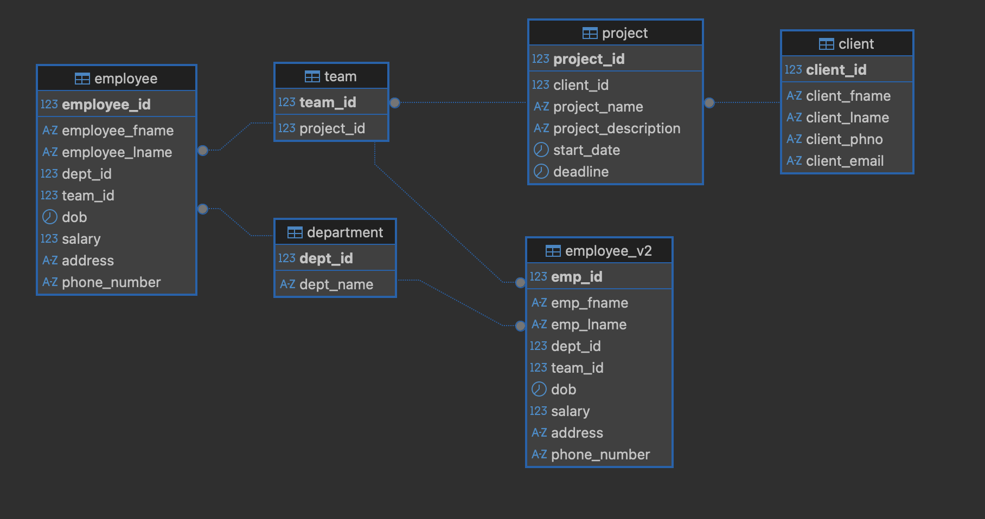

No. | Entities Involved | Implemented Relationship (Database) | Explanation
1 | Employee ↔ Department | Many-to-One (N:1) | The real-world scenario allows employees to work in multiple departments, but the redesigned employee_v2 table intentionally restricts each employee to exactly one department to eliminate redundancy and ensure data consistency.
2 | Employee ↔ Team | Many-to-One (N:1) | Employees may work in multiple teams in real life, but the current schema enforces a single team per employee to simplify the model and avoid duplication.
3 | Team ↔ Project | Many-to-One (N:1) | Multiple teams can work on a single project and teams can work on multiple projects, but the current structure does not support this relationship correctly due to the absence of a junction table.
4 | Client ↔ Project | One-to-Many (1:N) | One client can own multiple projects, and each project is correctly linked to a single client using client_id as a foreign key.

Queries performed:

- I observed the execution time before and after indexing the emp_fname column and it actually gave the result with 0.236ms less time!

EXPLAIN ANALYZE
SELECT emp_id
FROM employee_v2
WHERE emp_fname = 'Pranav';

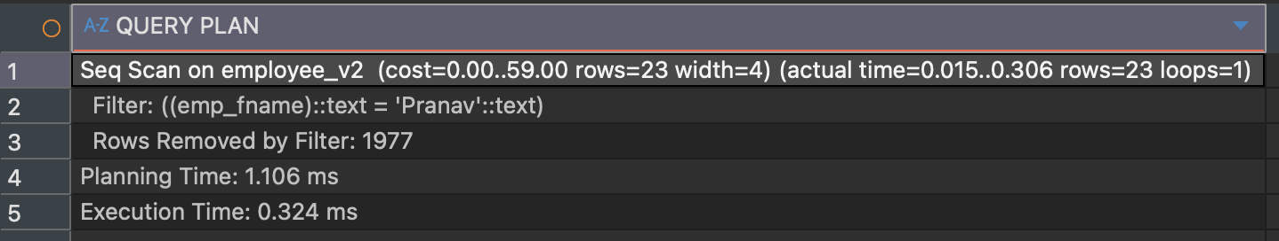

CREATE INDEX idx_employee_first_name ON employee_v2(emp_fname);

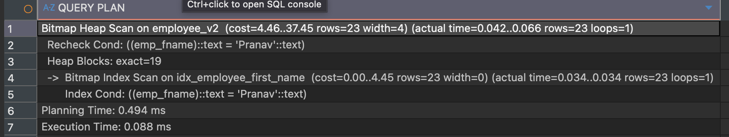

Employee Queries

- List all employees with their department and team
SELECT e.emp_id, e.emp_fname, e.emp_lname, d.dept_name, t.team_id
FROM employee_v2 e
JOIN department d ON e.dept_id = d.dept_id
JOIN team t ON e.team_id = t.team_id;
Shows all employees along with their department and team info.
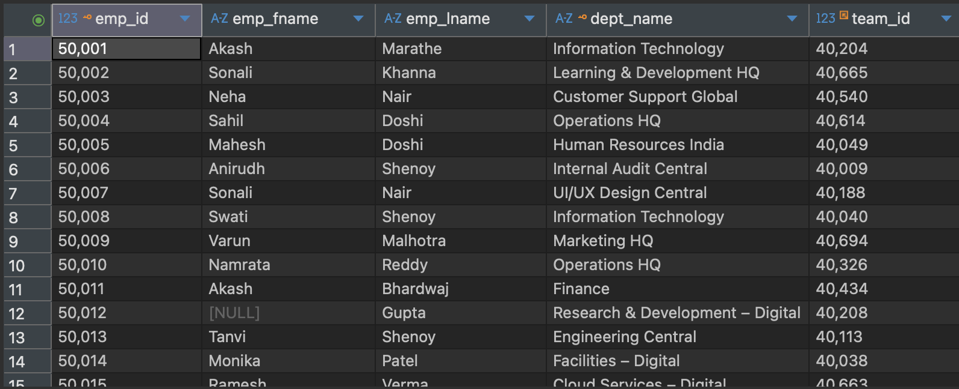
- Count employees in each department
SELECT d.dept_name, COUNT(*) AS employee_count
FROM employee_v2 e
JOIN department d ON e.dept_id = d.dept_id
GROUP BY d.dept_name
ORDER BY employee_count DESC;

Displays number of employees in each department.
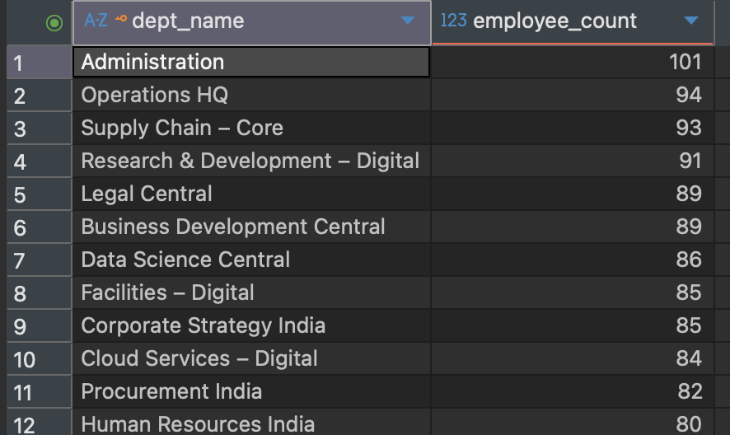
- Average salary per department
SELECT d.dept_name, ROUND(AVG(e.salary),2) AS avg_salary
FROM employee_v2 e
JOIN department d ON e.dept_id = d.dept_id
GROUP BY d.dept_name;
Shows the average salary for employees in each department.
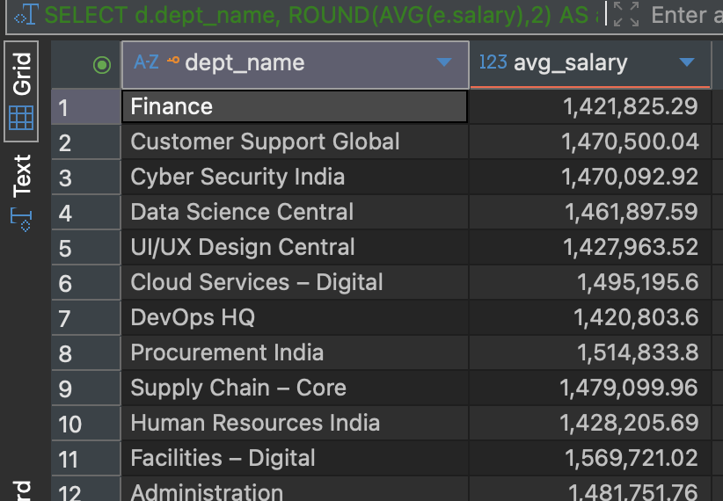
- Employees with missing info (NULLs)
SELECT count(emp_id)
FROM employee_v2
WHERE emp_fname IS NULL OR emp_lname IS NULL OR dob IS NULL OR address IS NULL;
Finds employees with incomplete personal information.

- Employees older than 50
SELECT emp_id, emp_fname, emp_lname, dob
FROM employee_v2
WHERE dob IS NOT NULL AND dob <= CURRENT_DATE - INTERVAL '50 years';
Shows employees who are above 50 years old.
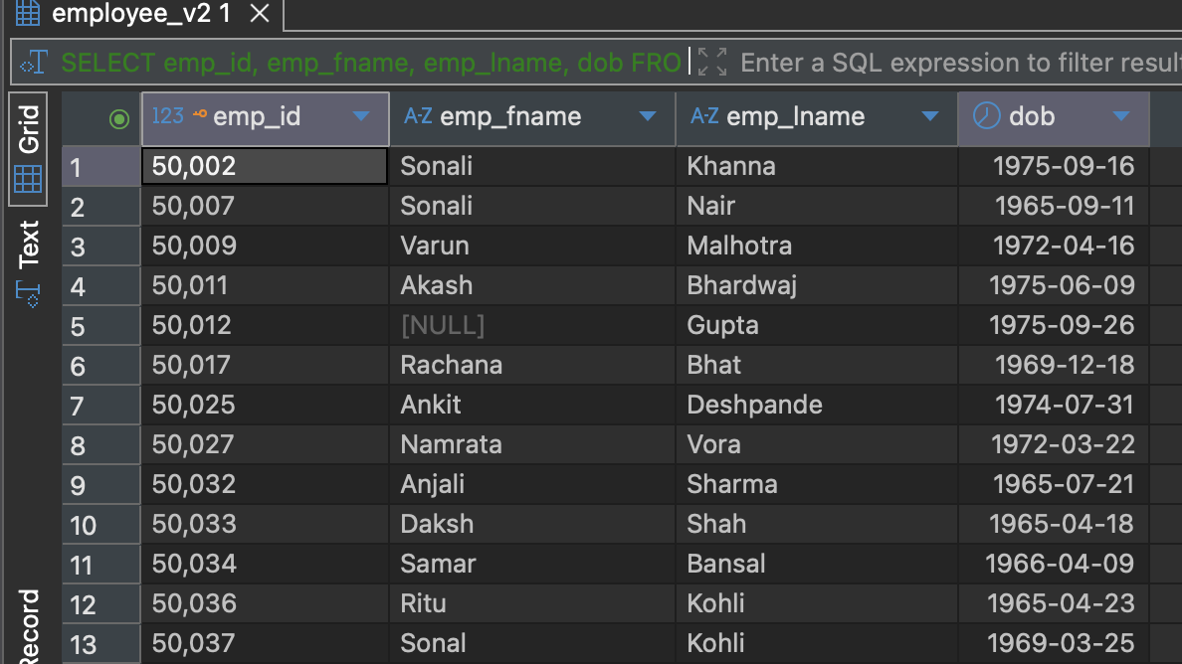
- Top 10 highest-paid employees
SELECT emp_id, emp_fname, emp_lname, salary
FROM employee_v2
ORDER BY salary DESC
LIMIT 10;
Lists the top 10 employees with the highest salary.
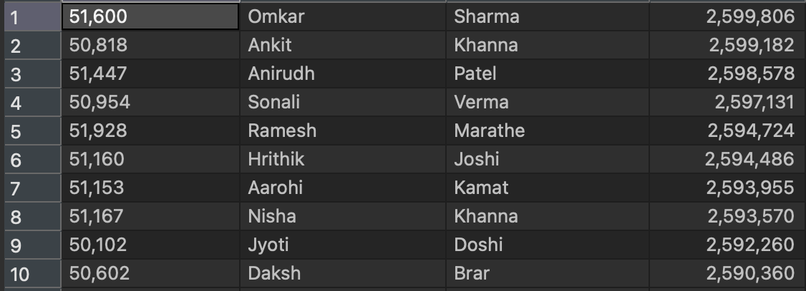
- Employees grouped by team
SELECT team_id, COUNT(*) AS total_employees
FROM employee_v2
GROUP BY team_id
ORDER BY total_employees DESC;
Shows number of employees in each team.
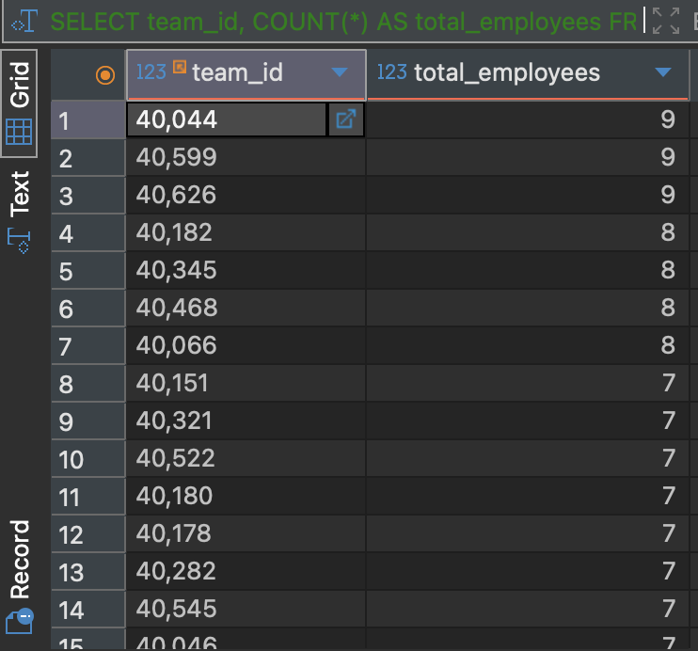

- Employees without address
SELECT emp_id, emp_fname, emp_lname
FROM employee_v2
WHERE address IS NULL;
Lists employees missing their address information.


Department Queries

- Departments with more than 80 employees
SELECT d.dept_name, COUNT(*) AS total_employees
FROM employee_v2 e
JOIN department d ON e.dept_id = d.dept_id
GROUP BY d.dept_name
HAVING COUNT(*) > 80;
Finds departments that have more than 80 employees.
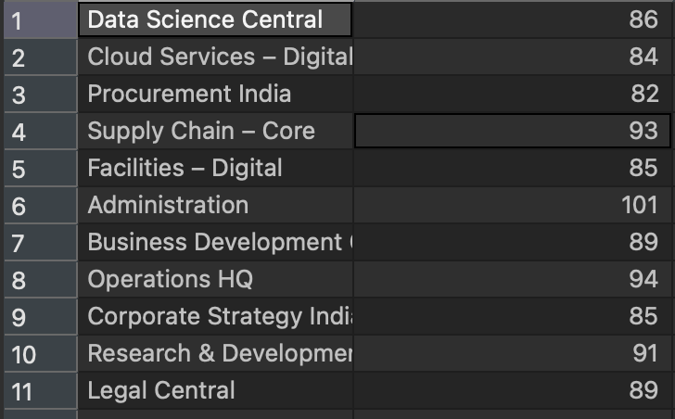
- Highest paid department
SELECT d.dept_name, SUM(e.salary) AS total_salary
FROM employee_v2 e
JOIN department d ON e.dept_id = d.dept_id
GROUP BY d.dept_name
ORDER BY total_salary DESC
LIMIT 1;
Shows which department pays the most overall salary.
- Departments with no employees
SELECT d.dept_name
FROM department d
LEFT JOIN employee_v2 e ON e.dept_id = d.dept_id
WHERE e.emp_id IS NULL;
Finds departments that currently have no employees.


Team Queries

- Teams with the most employees
SELECT team_id, COUNT(*) AS employee_count
FROM employee_v2
GROUP BY team_id
ORDER BY employee_count DESC
LIMIT 5;
Top 5 teams with the highest number of employees.

- Teams working on projects
SELECT t.team_id, p.project_name
FROM team t
JOIN project p ON t.project_id = p.project_id
Order by p.project_name;
Shows which projects each team is working on.
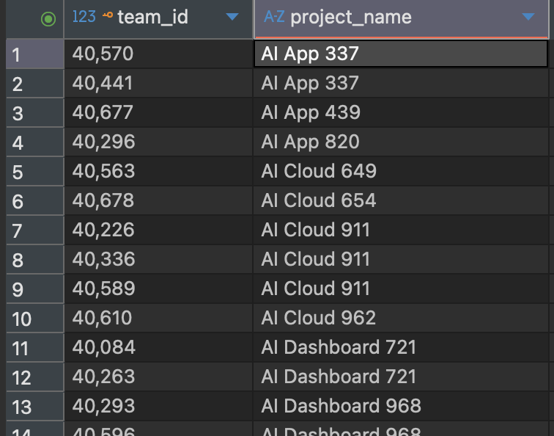
- Average employee salary per team
SELECT team_id, ROUND(AVG(salary),2) AS avg_salary
FROM employee_v2
GROUP BY team_id
ORDER BY avg_salary DESC;
Displays average salary of employees for each team.

- Teams with only one employee
SELECT team_id
FROM employee_v2
GROUP BY team_id
HAVING COUNT(*) = 1;
Identifies teams that have only one employee.

There are 115 such teams

Project Queries

- Active projects (current date between start_date and end_date)
SELECT project_id, project_name, start_date, deadline
FROM project
WHERE CURRENT_DATE BETWEEN start_date AND deadline;
Shows projects that are currently in progress.

- Projects with no team assigned
SELECT p.project_id, project_name
FROM project p
LEFT JOIN team t ON p.project_id = t.project_id
WHERE t.team_id IS NULL;
Finds projects that currently don’t have any teams assigned.
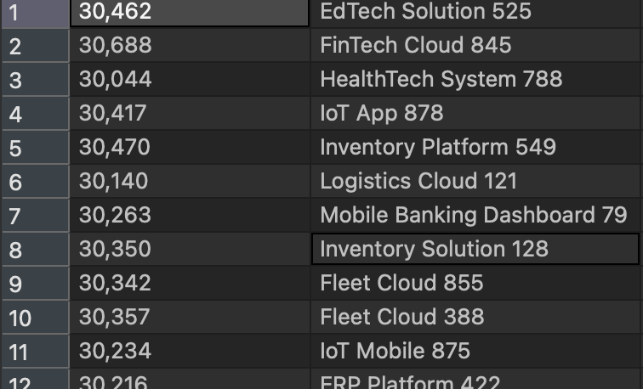
- Longest running project
SELECT project_id, project_name, deadline - start_date AS duration_days
FROM project
ORDER BY duration_days DESC
LIMIT 1;
Shows the project with the longest planned duration.
- Number of teams per project
SELECT p.project_name, COUNT(t.team_id) AS total_teams
FROM project p
LEFT JOIN team t ON p.project_id = t.project_id
GROUP BY p.project_name
ORDER BY total_teams DESC;
Displays how many teams are working on each project.
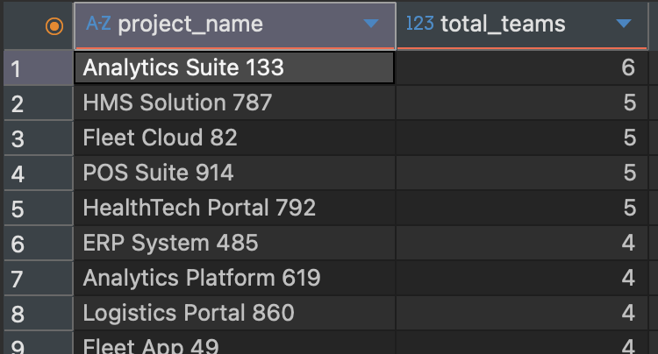

Client Queries

- Clients with multiple projects
SELECT c.client_fname, c.client_lname, COUNT(p.project_id) AS projects_count
FROM client c
JOIN project p ON c.client_id = p.client_id
GROUP BY c.client_fname, c.client_lname
HAVING COUNT(p.project_id) > 1;
Lists clients who have more than one project.
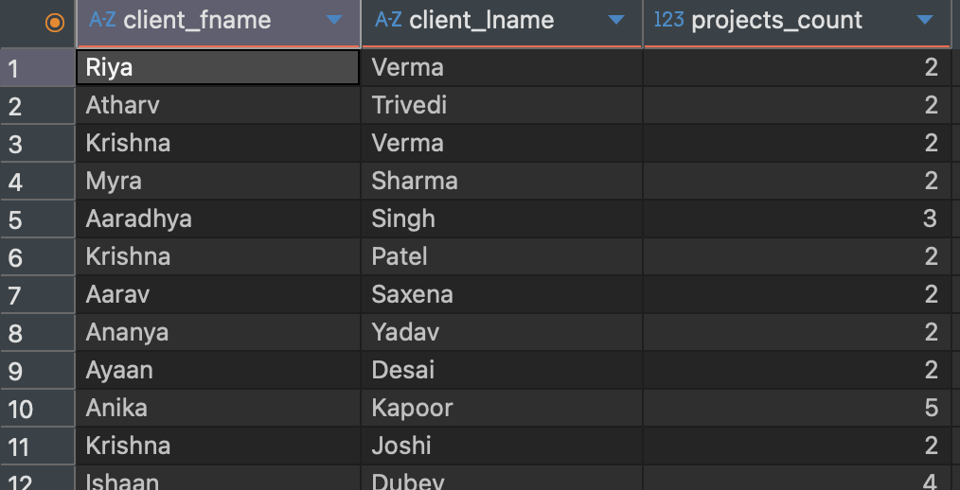
- Projects by client
SELECT c.client_fname, c.client_lname, p.project_name
FROM client c
JOIN project p ON c.client_id = p.client_id;
Shows which projects belong to which client.
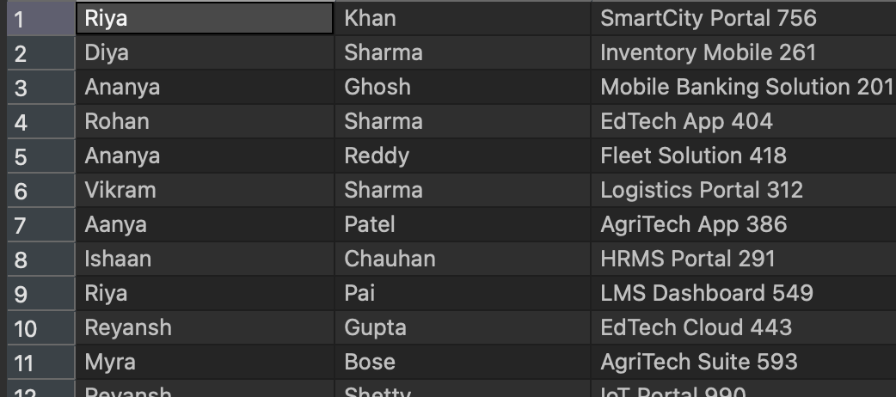
- Clients without projects
SELECT c.client_fname, c.client_lname
FROM client c
LEFT JOIN project p ON c.client_id = p.client_id
WHERE p.project_id IS NULL;
Finds clients that don’t have any projects assigned.


Salary & Performance Queries

- Employees earning below average salary
SELECT emp_id, emp_fname, emp_lname, salary
FROM employee_v2
WHERE salary < (SELECT AVG(salary) FROM employee_v2);
Finds employees whose salary is below the company average.
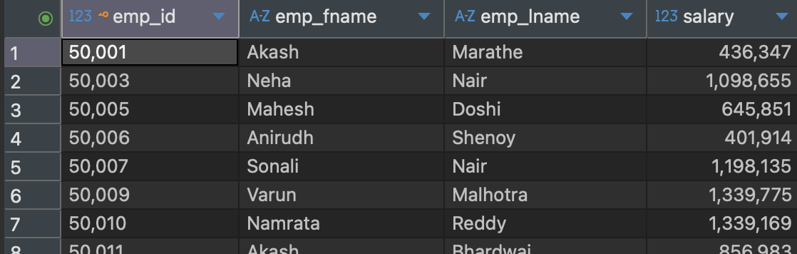

- Total salary per department
SELECT d.dept_name, SUM(e.salary) AS total_salary
FROM employee_v2 e
JOIN department d ON e.dept_id = d.dept_id
GROUP BY d.dept_name
ORDER BY total_salary DESC;
Shows the total salary expense per department.
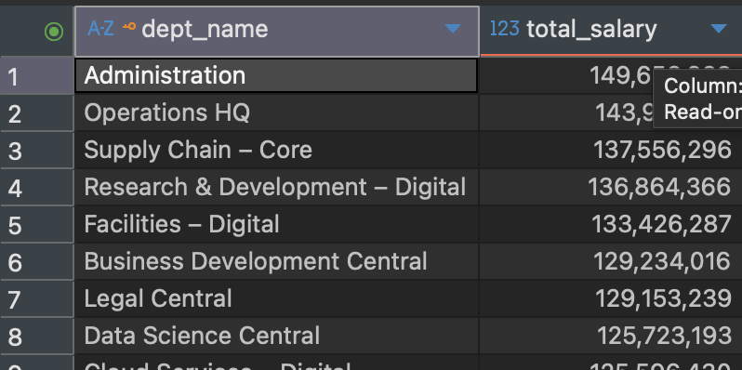
- Top 5 youngest employees
SELECT emp_id, emp_fname, emp_lname, dob
FROM employee_v2
WHERE dob IS NOT NULL
ORDER BY dob DESC
LIMIT 5;
Displays the 5 youngest employees in the company.


